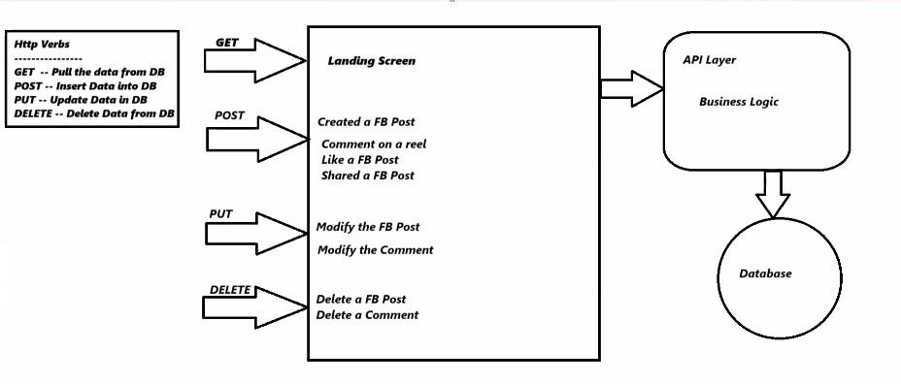**🔄 HTTP Verbs – CRUD Operations**

| **HTTP Verb** | **Action** | **Used For** |
| --- | --- | --- |
| GET | **Retrieve** data | View posts, search products, load feeds |
| POST | **Create** new data | Create post, add comment, add to cart |
| PUT | **Update** existing data | Edit profile, update cart quantity |
| DELETE | **Remove** data | Delete post, remove cart item |

**🧱 Three-Layer Architecture**

| **Layer** | **Purpose** | **Examples** |
| --- | --- | --- |
| **Presentation Layer** | UI/UX – What the user sees | React, Angular, Facebook homepage, Amazon UI |
| **API Layer** | Business logic & HTTP verbs | Handles requests/responses, validates input |
| **Database Layer** | Data storage and retrieval | Stores posts, products, users, orders |